

**Kofax SmartHub Connector**

**Salesforce Connector with KTA**

May 2021  
Version 1.0

Table of Contents

Overview 3

What is the Kofax Salesforce Connector? 3

Why Kofax Smart Hub? 3

Salesforce Connector Architecture 3

Configuration and Usage 4

How do I download the Salesforce Connector project from SmartHub? 4

Prerequisites 4

Required Set Up 4

Document Ingestion into KTA 9

How do I know if the record is created? 9

Limitations 9

Frequently Asked Questions 10

Overview

What is the Kofax Salesforce Connector?

The KTA Salesforce Connector allows users to send data – extracted by KTA – to your desired Salesforce deployment through the Salesforce API. Currently, the primary use case for the connector is for sending order forms and their extracted data through to Salesforce. We are looking to expand this capability in the future.

The KTA connector built with Salesforce provides processing of documents and images in various supported formats via the Salesforce REST APIs. A series of API calls are used to pull data from your Salesforce deployment in addition to the extracted data from your documents, and both data sources are combined which is used to create new records in Salesforce.

Why Kofax Smart Hub?

Kofax SmartHub is a digital showcase of assets connecting customers with pre-built, integrated components and solutions to extend their digital workforce. The Salesforce Connector solution will be easily available on SmartHub, built on top of Kofax’s Intelligent Automation platform. It accelerates customer automation journeys and reduces the need for custom development work. SmartHub also allows partners to expose their value-added solution to new prospects and customers.

Salesforce Connector Architecture

The Salesforce Connector uses the Salesforce REST API to pull data from your Salesforce instance as well as to push data to it. Here is the architecture diagram:

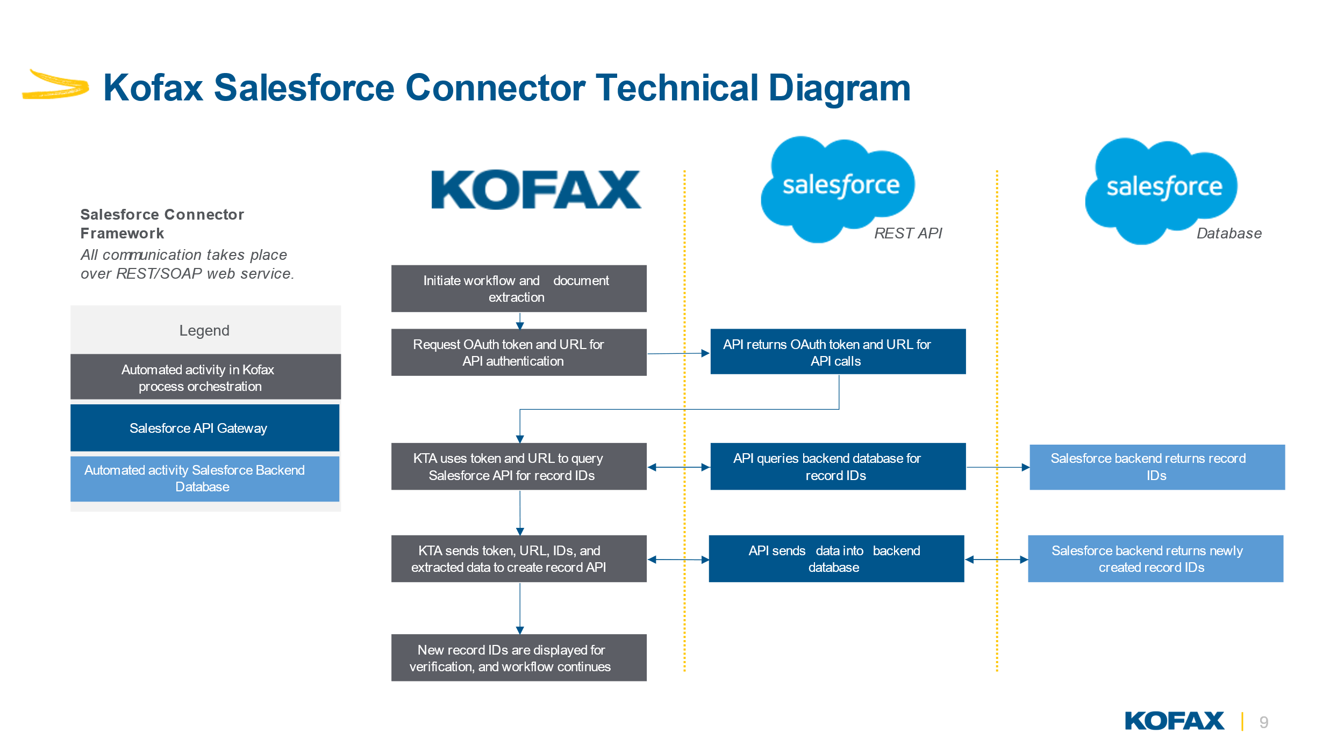

Configuration and Usage

How do I download the Salesforce Connector project from SmartHub?

The solution is available at <https://smarthub.kofax.com/> and downloadable from Github. Instructions to set up are down below as well as in the README.

Prerequisites

You will need the following in order to utilize this connector:

* KTA Version 7.9 or higher (data models feature is used in this)
* Saleforce Essentials, Professional, or Enterprise, Performance, Unlimited, Developer
  + Admin access or someone with admin access is required

Required Set Up

There are several steps needed to get the connector working, both in Salesforce and in KTA. The 4 main components are the Salesforce data objects (accounts, price book entries, etc.), the Salesforce Connected App (for your API keys), the KTA server variables (used to store API keys and credentials for access), and the KTA scanning workflow (extracts information out of documents and sends Salesforce).

Order Form Document Scanning

You will need to set up a document scanning process to extract the data you need:

|  |  |
| --- | --- |
| **Key** | **Value** |
| Account Name | Name of the account in Salesforce (exact match) |
| Price Book Entry Name | Name of the product’s price book entry in Salesforce (exact match) |
| Order Date | Date of the order |
| Quantity | Amount of the line item on order form |
| Unit Price | Price of each unit on order form |
| Billing City (optional) | The city where the order is billed to |
| Additionally, you will need to provide: | |
| Document Name | System variable from the document (“Order 1.jpg”) |
| Document ID | System variable for the KTA document ID (Instance ID) |
| Document File Type | System variable for the document’s file type (MIME type – “image/jpg”) |

You may use the one provided as a template, but are free to create your own as long as the above data is supplied to Salesforce

Case Form Document Scanning

You will need to set up a document scanning process to extract the data you need. Note that the blue section is all optional, but recommended to send as much information as possible:

|  |  |
| --- | --- |
| **Key (All Optional)** | **Value** |
| Account Name | Name of the account in Salesforce (exact match) |
| Contact Name | Name of the contact in Salesforce (exact match) |
| Priority | Level of priority you want (“high”, “medium”, “low” – Salesforce accepts anything, but these are the default options) |
| Subject | The subject of the case (“repair request for computer”) |
| Description | The detailed description of the case (“repair request for computer fan which is really loud”) |
| Supplied Name | The name of the person submitting the case form |
| Supplied Email | The email of the person submitting the case form |
| Supplied Phone | The phone of the person submitting the case form |
| Supplied Company | The company of the person submitting the case form |
| Additionally, you will need to provide: | |
| Document Name | System variable from the document (“Order 1.jpg”) |
| Document ID | System variable for the KTA document ID (Instance ID) |
| Document File Type | System variable for the document’s file type (MIME type – “image/jpg”) |

Salesforce Data Objects

1. Obtain access to a Salesforce instance and log in
   1. Either a test or production instance will work
2. Create or modify an account to exactly match the names identified on the form
3. (Only if using orders) Create or modify a price book entry to exactly match the names of the items in the form

Salesforce Connected App

1. Ensure you or someone you work with has administrator access to your Salesforce instance
   1. It is also recommended you switch to Salesforce Classic
2. Click Setup in the top right corner
3. In the Quick Find box in the top left, type “App Manager”
4. Select “App Manager”
5. Click “New Connected App”
6. Fill out the 3 required fields (you can name these something like “KTA Connector”)
7. Check the “Enable OAuth Settings” box
8. For Callback URL enter your KTA installation’s URL (i.e. [https://pf28mq4y.kofax.com](https://pf28mq4y.kofax.com/))
   1. This is not used but is still a required field
9. Under Selected OAuth Scopes, click “Manage user data via APIs (api)”, then click the “Add” arrow button
10. Scroll down to the bottom and click Save
11. Click Continue (may need to scroll up)
    1. You should now see your newly created Connected App
12. Find the first section labeled “API (Enable OAuth Settings)”
13. Click the “Manage Consumer Details” button
14. Click the Copy button next to Consumer Key and paste this somewhere easily accessible
15. Click the Reveal button next to Consumer Secret and click Copy, and keep this with your Consumer Key
16. Finally, you may also need to enable this setting to allow you to authenticate API calls: A screenshot of a computer

    Description automatically generated

KTA Server Variables

You will need to set up the KTA Server variables which are comprised of your login information needed to use the Salesforce REST API:

|  |  |
| --- | --- |
| **Key** | **Value** |
| Username | Username of the Salesforce account you are using |
| Password | Password of the Salesforce account you are using |
| ClientID | OAuth API key that is used to authenticate with the Salesforce API |
| ClientSecret | OAuth secret API key that is used to authenticate with the Salesforce API |
| Token | Security token that is appended to the password for instances that require it |
| ProdInstance | Boolean which directs the Salesforce Connector to the test/production instances |
| KTA_SDK_URL | URL for your KTA instance SDK. Example: <https://demo1-dev.dmoeukta.dev.kofaxcloud.com/services/sdk/> |

1. Log into KTA
2. Click Import on the left side menu
3. Import the downloaded Salesforce Connector from SmartHub
4. In the left menu, click System Data then Server Variables (can be changed at any time)
5. Find the variable named “KTA_SDK_URL” (you may need to change your category in the top right)
6. Change the base domain URL (the <https://XXXX.com>) to your instance’s URL, which you can find here: 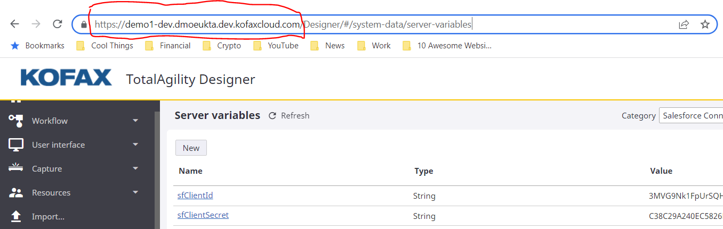
7. Click New and enter in the required info
   1. Name can be anything, something like “sfConsumerKey”
   2. Category should be “Salesforce Connector” unless you renamed it
   3. ID is auto populated
   4. Type is “String”
   5. Paste your Consumer Key for the value
8. Repeat this for your Consumer Secret, Salesforce username, Salesforce password, and Salesforce token
   1. Names can be anything, recommended format is “sfConsumerSecret”, “sfUsername”, and “sfPassword”, and “sfToken”
   2. Username is found in your Salesforce account (likely your email but not always)
   3. Password is your password which you use to log in to your username
   4. Token is your Salesforce security token (may or may not be enabled based on your instance settings)
      1. If you do not know this, you can reset this in your Setting -> Reset My Security Token
      2. Enter this as the value in KTA
   5. Same category, ID, and type as above
   6. Optionally, you can select the “Secure” box to obfuscate sensitive data like your password and Consumer Secret
9. Create the last server variable named “sfProdInstance” (or similar)
   1. Category and ID are the same as above
   2. Type is “Bool”
   3. Set the value to FALSE if you want to use a Salesforce Sandbox (test instance)
   4. Set to TRUE if you want to use a normal production instance
   5. If you are using a Trailhead Playground instance, set to TRUE
10. Click into the Add Order or Add Case process
11. Click the activity labeled “Salesforce Connector Service Group”
12. Fill out the first 6 parameters with the corresponding server variables you just created, in the “server variables” tab
    1. No need to touch the return parameters
    2. Client ID = Consumer Key
    3. Client Secret = Consumer Secret
13. Click OK, then at the top right click Save, Release, then Close and Unlock

Document Ingestion into KTA

Users have a lot of flexibility with how they ingest documents into KTA for extraction. There are 2 main methods to go about this.

It is recommended that documents are ingested by KTA through a scan form generated by KTA. This is used to kick off the document scan process that you set up, which will then pass the data into the Salesforce Connector.

You may also set up a document listener to watch a specific folder on your local machine, so if you move a document into that folder KTA will automatically process it. This works for individual users but is not as scalable for teams.

How do I know if the record is created?

When the process is complete, you will be presented with a form containing all the information about the new record that KTA has sent to your Salesforce deployment. This includes the record ID for the created record, as well as the record ID of the attached document.

You can then use this information to verify the record that was created within Salesforce, and make sure that everything is as expected. If they do not align, it is highly recommended to go over the extracted data as well as the information that is supplied to the connector.

Limitations

Orders

The Salesforce Connector can currently only process order forms with one (1) line item. Alternatively, you can scan the same form for each line item, making sure each extraction pulls out a separate line item. This is a feature we are looking to expand.

The names of the account and price book entry that are provided to the Salesforce Connector must exactly match the names in Salesforce. The connector queries the Salesforce API for objects by their name. If the names on the document do not exactly match the names in Salesforce, the query will not find the record and will not be able to perform the desired action

Cases

The Salesforce Connector can currently only create one (1) case from each scanned document.

The names of the account and contact that are provided to the Salesforce Connector must exactly match the names in Salesforce. These values are optional, so if you leave them blank it will not pull that information out. The connector queries the Salesforce API for objects by their name. If the names on the document do not exactly match the names in Salesforce, the query will not find the record and will not be able to perform the desired action

Frequently Asked Questions

Below is the list of possible questions gathered to answer the basic questions about storage and detection

How do you secure the transfer of the data? and what happens after the document is uploaded to the server?

Data transfer is handled via secure TLS connection. Each user is authenticated using an API key in the https header. Upon submitting a file to the server, a unique ephemeral environment is deployed to process the file. As soon as the analysis is complete, the environment is destroyed, and the result of the analysis is returned to the caller.

How many documents can the system process simultaneously?

The solution is designed to process documents in parallel and independently from one another. The maximum allowed time in the test to process the 1,000 documents simultaneously is 60 second. However, the order functionality can only support one (1) line item per order – if you have more you can simply run the same order form through once for each line item. The case functionality will also only create one (1) case per document.